Intermacs users can download their data in Excel format

Please see the below tutorial:

1. To access the data download feature in Intermacs, log in to the Intermacs website and look for the Reports tab, which should be located next to the Dashboard tab.

2. The “Reports” tab will bring you to a screen showing Live Data Downloads, please click here.

3. You will then be brought to this screen showing all forms available to download.

4. Click on your desired form and accept the disclaimer and terms and conditions.

5. Your form will now download in an excel format.

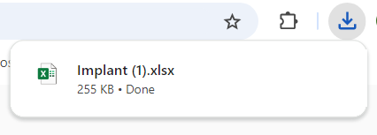

Please refer to (<https://intermacs.kirso.net/reports/>) if you have any questions at all.